Q 1
#define _CRT_SECURE_NO_WARNINGS
#include<iostream>
#include<fstream>
#include<string>
#include<cstring>
using namespace std;
enum acctype { UNKNOWN, SAVING, CURRENT };
class bankacc {
acctype type;
char name[100];
char accnum[100];
double balammount;
char bankname[100];
char bcode[100];
char city[100];
public:
static unsigned int currentacc;
static unsigned int savingacc;
bankacc() {
strcpy(name, "unknown");
strcpy(accnum, "unknown");
strcpy(bankname, "unknown");
strcpy(bcode, "unknown");
strcpy(city, "unknown");
balammount = 0;
type = UNKNOWN;
}

bankacc(char name[], char accNum[], acctype t, double bal, char bank[], char branch[], char c[]) {
strcpy(this->name, name);
strcpy(this->accnum, accNum);
strcpy(this->bankname, bank);
strcpy(this->bcode, branch);
strcpy(city, c);
balammount = bal;
type = t;
if (type == SAVING)
savingacc++;
else
currentacc++;
}

void deposit(double amount) {
balammount += amount;
}

void withdraw(double amount) {
if (amount <= balammount) {
balammount -= amount;
}
else {
cout << "Insufficient balance!" << endl;
}
}

void display() {
cout << endl;
cout << "Bank Name: " << bankname << " City:" << city << endl;
cout << "Branch Code: " << bcode << endl;
cout << "Depositor Name:" << name << endl;
cout << "Balance " << balammount << endl;
}

acctype gettype() {
return type;
}

static void getacccounts() {
cout << endl;
cout << "Saving Accounts: " << savingacc << endl;
cout << "Current Accounts: " << currentacc << endl;
}

void write(ofstream& out) {
out << name << " "
<< accnum << " "
<< type << " "
<< balammount << " "
<< bankname << " "
<< bcode << " "
<< city << "\n";
}
void read(ifstream& in) {
int t;
in >> name >> accnum >> t >> balammount >> bankname >> bcode >> city;
type = (acctype)t;
if (type == SAVING)
savingacc++;
else if (type == CURRENT)
currentacc++;
}
};
unsigned int bankacc::currentacc = 0;
unsigned int bankacc::savingacc = 0;

int main()
{
bankacc* accounts[100] = { NULL };
int count = 0;
ifstream inFile("Q1 accounts.txt");
if (inFile.is_open()) {
while (count < 100) {
accounts[count] = new bankacc();
accounts[count]->read(inFile);
if (inFile.fail()) {
delete accounts[count];
accounts[count] = NULL;
break;
}
count++;
}
inFile.close();
}

int choice;
do {
cout << endl;
cout << "1. Create Account" << endl;
cout << "2. Display All Accounts" << endl;
cout << "3. Delete Account" << endl;
cout << "4. Deposit Money" << endl;
cout << "5. Withdraw Money" << endl;
cout << "6. Exit" << endl;
cout << "Enter choice: ";
cin >> choice;
if (choice == 1) {
char name[50], acc[20], bank[50], branch[20], city[30];
int atype;
double bal;
cin.ignore();
cout << "Enter name: ";
cin.getline(name, 50);
cout << "Enter account number: ";
cin.getline(acc, 20);
cout << "Enter type (0=SAVING, 1=CURRENT): ";
cin >> atype;
acctype type;

if (atype == 0)
type = SAVING;
else
type = CURRENT;

cout << "Enter balance: ";
cin >> bal;
cin.ignore();
cout << "Enter bank name: ";
cin.getline(bank, 50);
cout << "Enter branch code: ";
cin.getline(branch, 20);
cout << "Enter city: ";
cin.getline(city, 30);

accounts[count] = new bankacc(name, acc, type, bal, bank, branch, city);
count++;
}

else if (choice == 2) {
if (count == 0) {
cout << "No accounts available to display!" << endl;
}
else {
for (int i = 0; i < count; i++)
accounts[i]->display();
bankacc::getacccounts();
}
}

else if (choice == 3) {
int index;
cout << "Enter index to delete (0 to " << count - 1 << "): ";
cin >> index;

if (count == 0) {
cout << "No accounts to delete!" << endl;
}
else if (index >= 0 && index < count) {

if (accounts[index]->gettype() == SAVING)
bankacc::savingacc--;
else if (accounts[index]->gettype() == CURRENT)
bankacc::currentacc--;

delete accounts[index];

for (int i = index; i < count - 1; i++) {
accounts[i] = accounts[i + 1];
}

accounts[count - 1] = NULL;
count--;
cout << "Account deleted successfully." << endl;
}
else {
cout << "Invalid index!" << endl;
}
}

else if (choice == 4) {
if (count == 0) {
cout << "No accounts available!" << endl;
}
else {
int index;
double amount;
cout << "Enter account index (0 to " << count - 1 << "): ";
cin >> index;
if (index >= 0 && index < count) {
cout << "Enter amount to deposit: ";
cin >> amount;
accounts[index]->deposit(amount);
cout << "Amount deposited successfully!" << endl;
accounts[index]->display();
}
else {
cout << "Invalid index!" << endl;
}
}
}

else if (choice == 5) {
if (count == 0) {
cout << "No accounts available!" << endl;
}
else {
int index;
double amount;
cout << "Enter account index (0 to " << count - 1 << "): ";
cin >> index;
if (index >= 0 && index < count) {
cout << "Enter amount to withdraw: ";
cin >> amount;
accounts[index]->withdraw(amount);
accounts[index]->display();
}
else {
cout << "Invalid index!" << endl;
}
}
}

else if (choice == 6) {
ofstream out("Q1 accounts.txt");

for (int i = 0; i < count; i++) {
accounts[i]->write(out);
}
out.close();
cout << endl << "Accounts saved. Goodbye!" << endl;
}

} while (choice != 6);

for (int i = 0; i < count; i++) {
delete accounts[i];
accounts[i] = NULL;
}

system("pause");
}
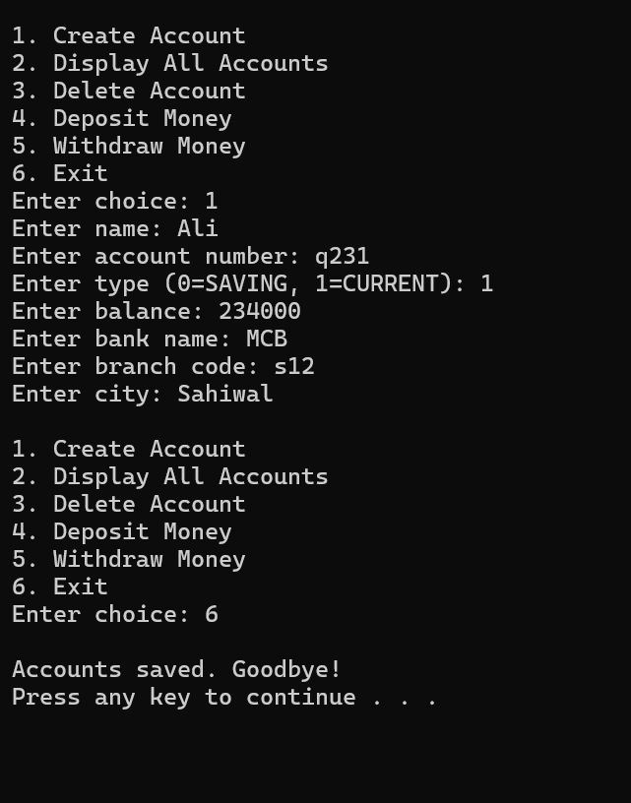

Q 2
#include<iostream>
#include<string>
using namespace std;
class hotdogstand {
public:
int id;
int sold;
static int totalsold;
hotdogstand() {
id = 0;
sold = 0;
}
hotdogstand(int id, int sold) {
this->id = id;
this->sold = sold;
totalsold += sold;
}

void justsold() {
sold++;
totalsold++;
}

int numsold() {
return sold;
}

static int TotalSold() {
return totalsold;
}
};
int hotdogstand::totalsold = 0;

int main()
{
hotdogstand stand1(1, 5);
hotdogstand stand2(2, 3);
hotdogstand stand3(3, 7);

stand1.justsold();
stand1.justsold();
stand2.justsold();
stand3.justsold();

cout << "Stand 1 \n" << "ID: " << stand1.id << " sold: " << stand1.numsold() << endl;
cout << "Stand 2 \n" << "ID: " << stand2.id << " sold: " << stand2.numsold() << endl;
cout << "Stand 3 \n" << "ID: " << stand3.id << " sold: " << stand3.numsold() << endl;

cout << "Total hot dogs sold: " << hotdogstand::TotalSold() << endl;
}

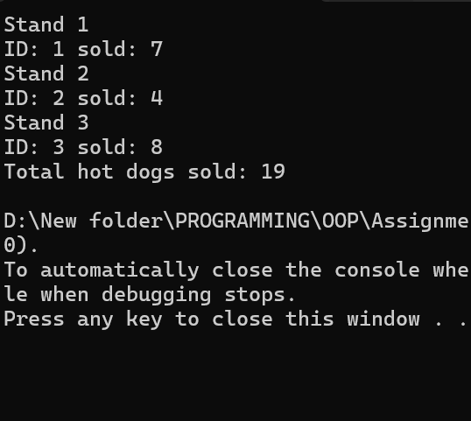

Q 4
#include<iostream>
#include<string>
using namespace std;
class tollbooth {
unsigned int tcars;
double tammount;
unsigned int paycars;
unsigned int nopaycars;
public:

tollbooth() {
tcars = 0;
tammount = 0;
paycars = 0;
nopaycars = 0;
}
void payingcar() {
tcars++;
paycars++;
tammount += 50;
}
void nopaycar() {
tcars++;
nopaycars++;
}
void display() const {
cout << endl;
cout << "Total number of cars: " << tcars << endl;
cout << "Total ammount collected: " << tammount << endl;
cout << "Toll paying cars: " << paycars << endl;
cout << "No toll paying cars: " << nopaycars << endl;
}
};
int main()
{
tollbooth obj;
int choice;

do {
cout << "\nTollbooth Menu:\n";
cout << "1. Paying Car\n";
cout << "2. Non-Paying Car\n";
cout << "3. Display Totals\n";
cout << "4. Exit\n";
cout << "Enter choice: ";
cin >> choice;

switch (choice) {
case 1:
obj.payingcar();
cout << "Recorded a paying car" << endl;
break;
case 2:
obj.nopaycar();
cout << "Recorded a non-paying car" << endl;
break;
case 3:
obj.display();
break;
case 4:
cout << "Exiting program" << endl;
break;
default:
cout << "Invalid choice! Try again" << endl;
}
} while (choice != 4);

}
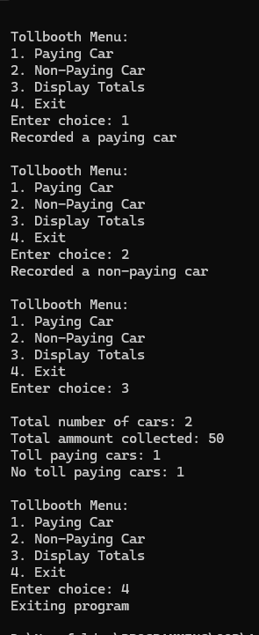

Q 5

#include<iostream>
using namespace std;
class Time {
int hours;
int mins;
int sec;
public:
Time() {
hours = 0;
mins = 0;
sec = 0;
}
Time(int hours, int mins, int sec) {
this->hours = hours;
this->mins = mins;
this->sec = sec;
}
void display() const {
cout << endl;
cout << hours << ":" << mins << ":" << sec << endl;
}
void add(const Time t1, const Time t2) {
this->sec = t1.sec + t2.sec;
this->mins = t1.mins + t2.mins + sec / 60;
this->sec = sec % 60;
this->hours = t1.hours + t2.hours + mins / 60;
this->mins = mins % 60;
this->hours = hours % 24;
}
};

int main()
{
const Time t1(12, 56, 43);
const Time t2(5, 45, 32);
Time t3;
cout << "Time 1:" << endl;
t1.display();
cout << "Time 2:" << endl;
t2.display();
t3.add(t1,t2);
cout << "Time 3:" << endl;
t3.display();
}
